**Module Overview**

Welcome to this module on Cloud.

In the previous module, you learnt what machine learning is and learnt about its applications. Next, you understood the role of cloud in machine learning applications and learn about the different steps involved in productionising a machine learning model.

**In this module**

You will get a deeper understanding of the evolution of the cloud. You will first explore the disadvantages of the procedure followed before the cloud. Then you will understand its advantages by exploring the essential characteristics, and various deployment and service models. Moving further, you will get hands-on experience of using the services of a popular cloud service provider.

Now, let’s quickly go through the module overview.

Play Video

So, by now, you must have briefly understood the need for cloud computing. The broad topics that will be covered in this module are as follows:

1. Difference between traditional data centres and cloud computing
2. Fundamental technologies of cloud
3. Advantages of cloud computing
4. Cloud deployment models
5. Cloud service models
6. Hands-on experience with AWS

**In this session**

You will first learn about the procedure followed before the evolution of cloud. Next, you will explore the problems faced before the emergence of cloud computing and understand how cloud helped solved these problems. Before deep-diving into the benefits of cloud computing, you will learn about the fundamental technologies that made cloud computing possible. Then you will learn about the essential characteristics of cloud by exploring its benefits in detail.

**Traditional Computing vs Cloud**

In this segment, you will learn about the traditional process followed before the evolution of cloud. Then you will get a brief understanding of cloud and how it helped solved the problems faced with the traditional process. So, let’s first understand the computing method that was followed before cloud.

Play Video

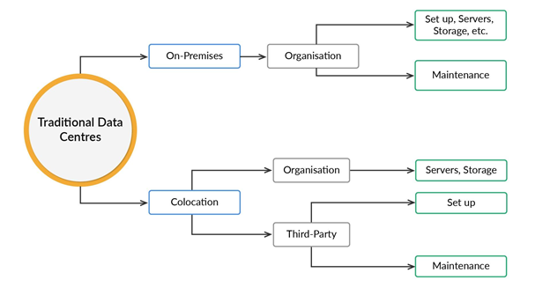

So, you learnt that traditional data centres are deployed in two ways, which are as follows:

1. **On-premises:**
   * In this setup, the organisation sets up and maintains the data centre by itself. It also owns all the equipment.
   * In some cases, networking between the data centre and the organisation’s office is taken care of by the network service provider.
2. **Colocation:**
   * In this setup, the organisation ties up with a third-party firm to set up and maintain its data centres.
   * The organisation provides the required computer servers, storage and networking, whereas the third-party firm provides the power, cooling and physical security.
   * In some cases, networking between the data centre and the organisation’s office is taken care of by the network service provider.

You also learnt about the problems faced with traditional data centres. Now, try to attempt the following question.

Questions:1/1

Mandatory

**Question 1**

Which of the following is/are a disadvantage/s of a traditional data centre?

Top of Form



High manual effort to maintain a data centre



Time-consuming



Higher costs



All of the above

Bottom of Form

Submit

Attempt 1 of 2

In the next video, you will learn about cloud computing and briefly explore its advantages, and also understand how it helps overcome the disadvantages of using traditional data centres.

Play Video

**Definition of Cloud computing (NIST - National Institute of Standards and Technology):**

***“A model for enabling ubiquitous, convenient, on-demand network access to a shared pool of configurable computing resources (e.g., networks, servers, storage, applications and services) that can be rapidly provisioned and released with minimal management effort or service provider interaction.”***

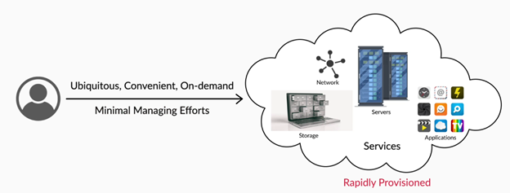

Here are some benefits of using cloud over traditional data centres:

1. Cloud has the ability to serve on-demand resources such as servers, applications, network configurations and services. Users can provision these resources when required with just a single click.
2. Users can instantaneously (manual or automatic way) increase or decrease the number of resources they require from the cloud.

# Virtualisation

Now, it’s time for you to understand the basic technologies that made cloud computing possible. The backbone of cloud computing is the ability to run multiple individual systems on a single hardware. Let’s learn about the technology that enables this operation.

Replay

Mute

Current Time 2:47

/

Duration 2:47

Loaded: 100.00%

1x

Playback Rate

Quality Levels

Picture-in-PictureFullscreen

Virtualisation enables multiple operating systems to run on the same hardware. You also explored its architecture by comparing it with traditional architecture. The architecture that is followed in typical laptops is Traditional architecture, whereas virtualisation architecture is used by some cloud service providers to run multiple virtual machines on a single hardware.

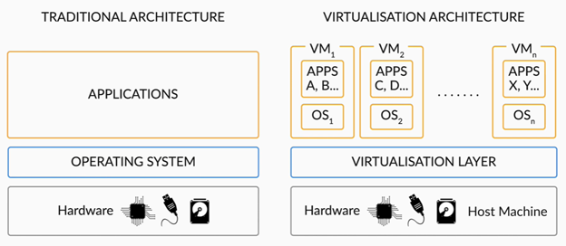

keyboard\_arrow\_leftkeyboard\_arrow\_rightQuestions:1/3

Mandatory

**Question 1**

Select all the true statements.

Top of Form



The hardware on which the virtualisation layer runs multiple operating systems is called a host machine.



The virtual machines running on the virtualisation layer are called guest machines.



The multiple machines running on the same hardware using a virtualisation layer are called virtual machines.



The hardware on which the virtualisation layer runs multiple operating systems is called a virtual machine.

Bottom of Form

Submit

Attempt 1 of 2

Now, you must have understood that the virtualisation layer helps to decouple the hardware from the operating system. However, you must be wondering how this decoupling happens. In this video, you will learn what exactly allows the virtualisation layer to share hardware among multiple virtual machines.

Play Video

You have learnt that the Hypervisor in the virtualisation layer controls and shares the hardware among multiple virtual machines. Then you There are two types of hypervisors and you also explored the Bare-metal/native Hypervisor.

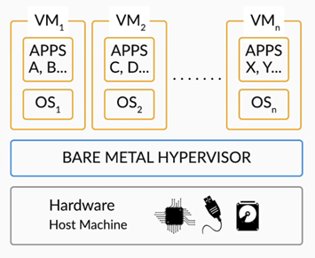

You also learnt that the bare-metal hypervisor resides on the hardware and enables to run multiple virtual machines on top of it. But, is there a way to create this virtual environment if you are working on a typical machine, where the operating system resides directly on the hardware? Yes, and this is where type 2 hypervisor comes into the picture. Let’s quickly learn about it from Vinod.

Play Video

You explored the other type of hypervisor, which is hosted hypervisor, and understood its architecture. Here, the hosted hypervisor runs on top of the host operating system, which resides on the hardware. This is why the hosted hypervisor is a bit slower than a bare-metal hypervisor.

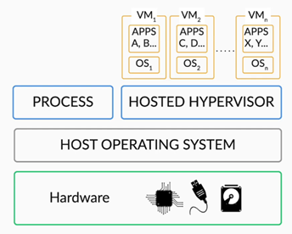

|  |  |
| --- | --- |
| **Bare-metal hypervisor (Type 1)** | **Hosted hypervisor (Type 2)** |
| It resides directly on the hardware. | It interacts with the hardware through the host operating system. |
| It is faster, as it directly interacts with the hardware. | It is a bit slower when compared to the bare metal hypervisor, as it interacts with the hardware through the host operating system. |

Now, try to answer the following questions.

keyboard\_arrow\_leftkeyboard\_arrow\_rightQuestions:1/5

Mandatory

**Question 1**

Which one of these is a bare-metal/native hypervisor?

Top of Form



Microsoft Virtual PC



Oracle Virtual Box



VMware ESX



KVM

Bottom of Form

***Virtual Machine:****It is an isolated logical entity capable of running software programs or guest operating systems that exhibit the behaviour of a separate computer.*

# Containerisation

Using virtualisation, you can deploy applications on multiple virtual machines. Though you require only a few specific resources to run the application, you need to load the entire operating system in a virtual machine and then deploy the application.

Using containerisation, you can deploy the application in containers, where you will be provided with only those resources that are required for running it. This is faster than creating a virtual machine and deploying an application. Let’s learn more about it through an example.

Play

Mute

Current Time 1:43

/

Duration 3:24

Loaded: 82.49%

1x

Playback Rate

Quality Levels

Picture-in-PictureFullscreen

Now, you must have understood that containerisation is OS-based virtualisation. Here, the operating system is virtualized by sharing the OS kernel among containers. These containers are isolated from each other. Each container loads only the libraries required to run an application. The container engine, which resides in the host operating system, is responsible for sharing the OS kernel among containers.

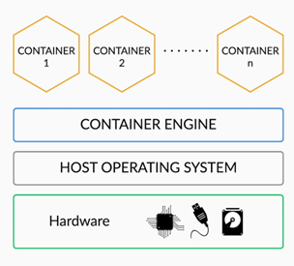

The differences between virtualisation and containerisation:

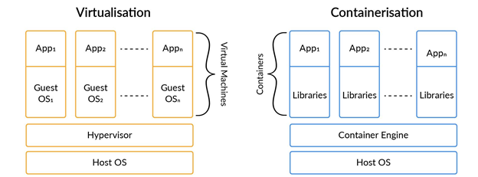

|  |  |
| --- | --- |
| **Virtualisation** | **Containerisation** |
| It is a hardware-level virtualisation. | It is operating system-level virtualisation. |
| It loads the complete OS for an application to run. | It loads only the required libraries for an application to run. |
| It is heavier than containers, as it loads the complete operating system for deploying an application. The size of a virtual machine is usually in GBs. | It is lighter than virtual machines, as it loads only the required libraries for deploying an application. The size of containers is usually in MBs. |
| As Virtual machines are heavier than containers, the process of launching a new virtual machine is slower. | As containers are lighter than virtual machines, the process of launching a new container is faster. |

Now, based on all that you have learnt thus far, answer the following question.

keyboard\_arrow\_leftkeyboard\_arrow\_rightQuestions:1/2

Mandatory

**Question 1**

Select all the true statements.

Top of Form



Virtual Machine loads the entire operating system to deploy any application



Virtual Machine loads only the required libraries for deploying an application



Container loads only the required libraries for deploying an application



Container loads the entire operating system to deploy any application

Bottom of Form

Submit

Attempt 1 of 2

In the upcoming videos, you will understand the essential characteristics of the cloud by exploring its benefits.

**Essential Characteristics of Cloud**

In this segment, you will understand the essential characteristics of the cloud by exploring its advantages over traditional data centres. Let's hear from Vinod.

Replay

Mute

Current Time 3:44

/

Duration 3:44

Loaded: 100.00%

1x

Playback Rate

Quality Levels

Picture-in-PictureFullscreen

As you learnt, some of the benefits of the cloud are as follows:

1. **Cost-efficiency:** This is possible due to one of the cloud characteristics, which is Measured Services. With this service, resources like storage, processing and bandwidth, etc. can be managed and controlled by the user. This enables the transparency of usage between the cloud provider and the user.
2. **Rapid Elasticity:** With this characteristic, the cloud can provision resources as per the requirement and cancel them if the resources are not required. The cloud can scale up and scale down based on requirements. This makes the user feel like the cloud is unlimited.

In the next video, you will learn about some more essential characteristics of the cloud by exploring its other benefits.

Play Video

The cloud offers an approach to managing its resources and infrastructure using definition files such as JSON files (also called templates).

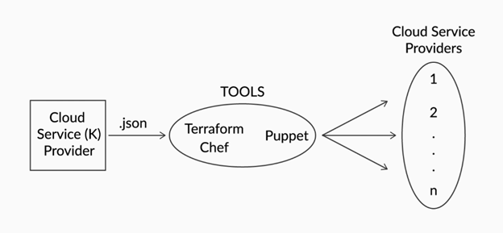

These JSON files are used to store the required infrastructure. These files can be used at any time to get back or recreate the infrastructure. With this Infrastructure as Code(IaC) approach, you can save the infrastructure and switch between multiple cloud service providers using tools such as **Ansible, Terraform, Chef, Puppet**, etc.

The ‘**Multi-tenancy**’ of the cloud allows multiple companies to have their data isolated on the same physical hardware. This enables the users to choose the region where their data should reside. However, the exact physical device on which their data resides is not known to the user. Here, VM’s are not shared among the users; they are allocated to individuals. Multi-tenancy allows users to share cloud resources.

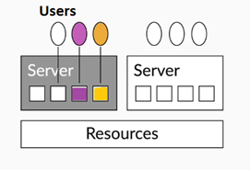

Let’s understand this in detail through an example. Consider an organisation running on a traditional data centre. It wants to provide services and resources to its three clients A, B and C, and the available storage is 1,500GB. Storage of 500GB is allocated to each of the clients, but client A is utilising only 100GB, client B is utilising only 200GB, and client C exceeds the 500GB storage limit and requests for an additional 100GB. To address client C’s issue, the organisation needs to purchase more storage and allocate it to the client.

In the above case, you can see that 400GB space at client A and 300GB space at client B is idle, yet the organisation is spending to get more storage. Whereas in the cloud, shareable storage of 1,500GB will be present, and this storage is completely shared among the clients. If client A is utilising only 100GB, client B is utilising only 200GB and client C exceeds the 500GB storage limit and requests for an additional 100GB, the cloud service provider can allocate the storage from the 700GB of idle storage available after 100+200+500GB of the 1,500GB storage has been utilised by clients A, B and C.

Play Video

**Note: Vinod selects the Mumbai region to launch the virtual machine. However, you will be expected to work under the North Virginia region in the coming sessions.**

The Broad Network Access characteristic of the cloud enables users using various types of devices to connect with it. This is the case with traditional data centres as well.

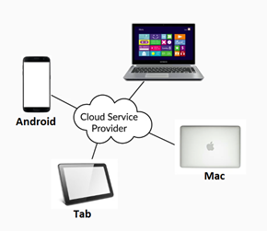

The **On-Demand Self-Service** of the cloud enables users to provision and release the cloud’s resources on their own with just a few clicks. Whereas in a traditional data centre, this process takes about a week. If you want to start a new machine in the cloud and require the storage, then you need not ask anyone to grant the storage. You can simply create an account with any of the cloud service providers and then start the machine and purchase the storage on your own with just a few clicks.

*Multi-tenancy is a cloud characteristic that allows users to share cloud computing resources. This allows multiple users to share the same hardware resources. But the physical device on which their data resides is completely isolated. The user is completely unaware of the physical device on which their data resides.*

**On-Demand Self-Service**

**Feedback :**

*On-Demand Self-Service is one of the most attractive characteristics of the cloud. It allows the user to get the required resources or services from the cloud. The user does not require any support staff to provide them. The user can get access to them solitarily. But if the user wants to get all these resources in a conventional on-premise solution, it takes about a week.*

**Virtual machine**

**Feedback :**

*In Resource Pooling, multiple users from different companies can store their data on the same physical device by sharing the underlying hardware. Virtual machines are allocated for individuals. They are not shared among anyone.*

**Summary**

Here’s a summary of what you have learnt so far in this session:

1. First, you began with understanding the procedure followed before the cloud. Then you explored the issues faced with traditional data centres and learnt how cloud solved those issues. Then, you explored a few benefits of the cloud over traditional data centres.
2. After that, you understood the fundamental technology, i.e., virtualisation, which made cloud computing possible. You also learnt about the types of hypervisor.
   * Bare-metal/native

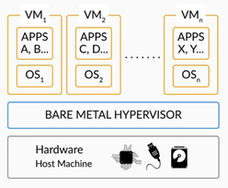

* + Hosted



* + Additional resources: There are different types of virtualisation as well. Please refer to [**this**](https://www.redhat.com/en/topics/virtualization/what-is-virtualization)link for more information.

1. After that, you learnt about containerisation and also explored its architecture. Then you understood how containerisation is different from virtualisation
2. Later, you learnt about the essential characteristics of the cloud by exploring its various benefits. The essential characteristics of the cloud are:
   * Measured Services
   * Rapid Elasticity
   * Resource Pooling
   * Broad Network Access
   * On-Demand Self-Service

*Infrastructure as Code (IaC) is the process of managing and provisioning cloud resources through definition files such as JSON files. Once the JSON file is populated with the necessary infrastructure requirements, it can then be fed into tools that are connected to the cloud service provider to create the infrastructure.*

**Resource Pooling**

**Feedback :**

*With the given resources, resource pooling enables the users to share the resources among themselves. Hence, both wastage and shortage will not occur at the same time. If there is a shortage for some users, they can access the shared resources.*



**Virtualisation**

**Feedback :**

*Virtualisation is a process of creating a virtual physical environment. It provides a virtual partition of the CPU, storage, etc., which allows you to virtually partition single physical hardware (server) into multiple virtual machines.*

*Therefore, you can use only one server and launch multiple virtual machines on top of it. This way, ‘SocOrg’ can decrease the number of servers they use.*

Introduction to Machine Learning and Cloud keyboard\_arrow\_right Module 3 keyboard\_arrow\_right Session 2

Deployment and Service Models

**Cloud Deployment Models**

By now, you must have understood that to avail benefits like on-demand self-service, rapid elasticity, measured services, etc., users need to deploy their applications on the cloud. However, there are various deployment models for each application, and each of these models has its own set of benefits. So, let’s learn about them from Vinod in the next video.

Replay

Mute

Current Time 3:43

/

Duration 3:43

Loaded: 100.00%

1x

Playback Rate

Quality Levels

Picture-in-PictureFullscreen

So, as you learnt, the most popular cloud deployment model is a public cloud.

**Public Cloud**

A public cloud platform offers services via a third party to all its users by allowing them to access the resources over the Internet. The cloud provider owns and manages all physical devices, such as servers, storage devices, etc., and provides access to the users. Here are some of the advantages and disadvantages of a public cloud:

**Advantages:**

1. It is highly scalable. It offers flexibility to either scale up or down the usage of resources as per the demand or based on a user’s request.
2. It is also cost-effective. Users of a public cloud have to pay for only what they use.

**Disadvantages:**

1. A public cloud might have security issues.
2. It is not 100% customisable as per an organisation’s requirements.

**Private Cloud**

In a private cloud, the resources are provisioned to only an authorised user. Here the user can be an organisation with multiple consumers. Here, the user can own and manage the resources or a third party can manage for the user or any combination of them can be possible. It can exist on or off premises of the organisation. However, as discussed in the video, a private cloud is different from on-premises data centres. Here are some of the advantages and disadvantages of a private cloud:

**Advantages:**

1. It provides high security and also restricts access only to authorised users. Hence, this kind of infrastructure is generally preferred in financial institutions like banks, insurance firms, etc.
2. It provides high control over the resources.

**Disadvantages:**

1. It is not cost-effective when compared with a public cloud.
2. It has limited scalability and can be scaled only up to the internal hosted resources.

Now, let’s consider a scenario: Say, there is a community of organisations that wish to work on the common data privately, without letting such information be disclosed to organisations external to the community. Now, do they have to create multiple private clouds to meet this requirement? The answer is No. This is where the community cloud model comes into the picture. You will learn more about this in the upcoming video.

Play Video

**Community Cloud**

A community cloud platform offers services to a group of organisations to access the resources. Here, the setup, infrastructure, resources, etc are shared among a group of organisations that belong to the same community or geographical area. Here are some of the advantages and disadvantages of a community cloud:

**Advantages:**

1. The cost of maintenance can be shared among the organisations in the community.
2. It is more secure than a public cloud and less expensive than a private cloud.

**Disadvantages:**

1. It is difficult to distribute the responsibilities among the organisations in a community.
2. It is difficult to segregate the data among the organisations in a community.

**Hybrid Cloud**

A hybrid cloud is a combination of a public and a private cloud. For example, it could be a combination of private cloud storage with public services to create more value out of the cloud infrastructure. Also, it allows data and application sharing between these two cloud environments. Here are some of the advantages and disadvantages of a hybrid cloud:

**Advantages:**

1. A private cloud is secure, and hence, a hybrid cloud is secure as well.
2. Scalability: you already know that the public cloud is scalable. Therefore, the hybrid cloud which is the combination of public and private cloud is also scalable.
3. Users can access both the private and the public cloud as per their requirements; thus, a hybrid cloud offers flexibility.
4. Public cloud is cost-effective, hence hybrid cloud is also cost-effective if the user wants to use the public cloud properties.

**Disadvantages:**

1. **Complex networking problems:** Due to the complexity of having the public and the private cloud, there would be an issue in configuring the network.
2. **Organisation’s security compliance:** Both the public and the private cloud should comply with the organisation’s security norms, and it is not easy to set up the clouds to meet this requirement.

So far in this segment, you have learnt about various cloud deployment models. Now, to deploy your applications on the cloud, you also need to know about the various cloud service providers. In the upcoming video, you will learn about some of the popular cloud service providers in the world today.

Play Video

So, in the video, you learnt about three popular cloud service providers, namely, [Amazon Web Service](https://aws.amazon.com/), [Microsoft Azure](https://azure.microsoft.com/en-in/) and the [Google Cloud Platform](https://cloud.google.com/).

Now that you have learnt about the different cloud deployment models and popular cloud service providers, try and answer the following questions.

keyboard\_arrow\_leftkeyboard\_arrow\_rightQuestions:1/4

Mandatory

**Question 1**

Select all statements that are true:

Top of Form



A private cloud consists of computing resources used exclusively by one business or organisation.



On-premises traditional data centres follow all the basic cloud characteristics.



In a public cloud, the resources (like servers and storage) are owned and operated by a third-party cloud service provider and are delivered over the Internet.



A public cloud consists of computing resources used exclusively by one business or organisation.

Bottom of Form

Submit

Attempt 1 of 2

Now, the services offered by cloud service providers can be classified into various categories. You will learn about these in the next segment.

**Cloud Service Models**

The services offered by cloud service providers are classified into three categories, namely,   
**IaaS**, **PaaS**and **SaaS**. Let’s watch the upcoming videos where you will explore each of them in detail.

Play Video

So, as you’ve just learnt, the IaaS allows customers access the cloud infrastructure resources, such as networking features, data storage space and virtualised servers (virtual or on dedicated hardware), from a cloud service provider. It is an on-demand service. It offers users the highest level of flexibility and management control over the resources.

In the video, you also learnt about the three different types of IaaS, which are as follows:

1. Virtual machines on a shared physical server
2. Virtual machines on a dedicated physical server
3. Dedicated bare-metal physical server

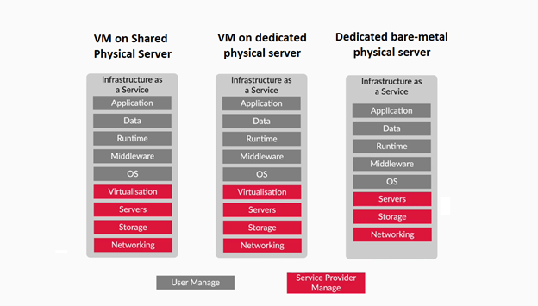

Here are some of the advantages of Infrastructure as a Service:

1. The service provider provides the infrastructure, and the user has to just install an operating system of their requirements and work on it.
2. The user can modify the architecture as per their requirements since it is basic cloud infrastructure.
3. The user has full control over all the computing resources.



So far, you have learnt about one of the cloud service models, namely, IaaS. In the next segment, you will learn about the other two cloud service models, namely, PaaS and SaaS

**Cloud Service Models**

The services offered by cloud service providers are classified into three categories, namely,   
**IaaS**, **PaaS**and **SaaS**. Let’s watch the upcoming videos where you will explore each of them in detail.

Pause

Mute

Current Time 0:15

/

Duration 5:25

Loaded: 21.30%

1x

Playback Rate

Quality Levels

Picture-in-PictureFullscreen

2041292

So, as you’ve just learnt, the IaaS allows customers access the cloud infrastructure resources, such as networking features, data storage space and virtualised servers (virtual or on dedicated hardware), from a cloud service provider. It is an on-demand service. It offers users the highest level of flexibility and management control over the resources.

In the video, you also learnt about the three different types of IaaS, which are as follows:

1. Virtual machines on a shared physical server
2. Virtual machines on a dedicated physical server
3. Dedicated bare-metal physical server



Here are some of the advantages of Infrastructure as a Service:

1. The service provider provides the infrastructure, and the user has to just install an operating system of their requirements and work on it.
2. The user can modify the architecture as per their requirements since it is basic cloud infrastructure.
3. The user has full control over all the computing resources.

keyboard\_arrow\_leftkeyboard\_arrow\_rightQuestions:1/2

Mandatory

**Question 1**

Select whether the following statement is true or false.

Virtual machines on a dedicated physical server are more expensive than dedicated bare-metal physical servers.

Top of Form



True



False

Bottom of Form

Submit

Attempt 1 of 1

So far, you have learnt about one of the cloud service models, namely, IaaS. In the next segment, you will learn about the other two cloud service models, namely, PaaS and SaaS.

**PaaS and SaaS**

In the previous segment, you learnt about IaaS, which provides users with the required hardware, networking, storage and servers; it is the users’ job to install the required operating system and work. The users set up their own required custom environment to run their application. However, cloud service providers observed an overlap of custom environments utilised by various users. Hence, they decided to provide a custom environment along with IaaS in the Platform as a Service (PaaS) model. So, let’s watch the next video and learn more about this cloud service model.

Play Video

So, as you learnt, ***Platform as a Service (PaaS)***provides an environment for developers and companies to create, host and deploy applications. This helps developers to concentrate more on developing and running the applications, rather than setting up, configuring and managing infrastructures such as hardware and operating system. This allows the users to be more efficient in deploying their applications on the cloud, as they do not need to worry about resource allotment, capacity planning, software maintenance, patching, or any of the other undifferentiated heavy lifting involved in running their applications. This allows them to build, compile and run programs.

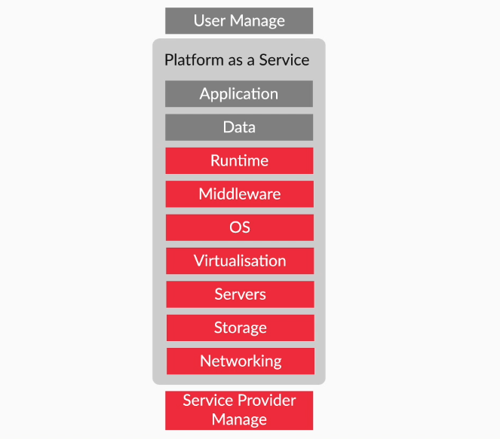

Here are some of the advantages and disadvantages of PaaS:

**Advantages:**

1. **Prebuilt platform**: PaaS provides an already built platform for users to build and run their applications.
2. It is a simple model to use and deploy applications.
3. **Low cost**: Since the platform is already built, the user needs to create only their applications. This reduces the costs related to hardware and software.

**Disadvantages:**

1. **Migration issues**: Migrating the user applications from one PaaS vendor to another might raise some issues.
2. **Platform restrictions**: The platforms provided by some vendors may have certain restrictions, for instance, the user can use only certain specified languages.

Software as a Service (SaaS) is a software licensing and delivery model in which software is licensed on a subscription basis and is hosted centrally. It basically means that a third party hosts an application on its servers or cloud, and makes it available to all its customers over the Internet. The customers can access these applications through the internet, and use the applications as well as the data for their own purposes.

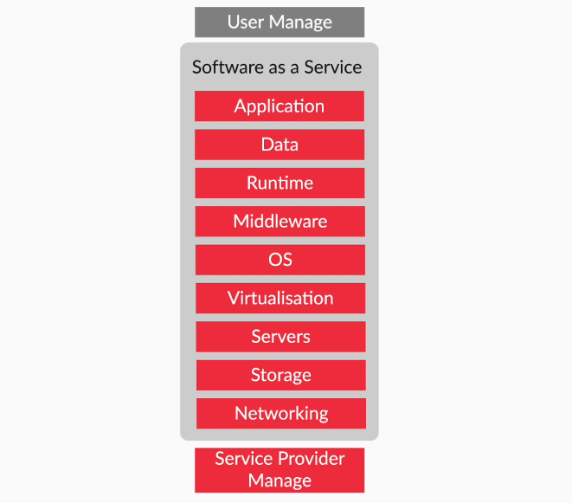

Here are some of the advantages and disadvantages of SaaS:

**Advantages:**

1. **Ease of access**: Users can access the applications on the server from anywhere using any Internet-connected device. Most types of internet-connected devices can access SaaS applications.
2. **Low maintenance**: Users need not update an application. The application is on the server, and it is the service provider’s responsibility to maintain the application.
3. **Quick setup**: Users do not require any hardware to install the application. The SaaS application is already present on the cloud.

**Disadvantages:**

1. **Lack of control**: Users do not have control over the SaaS applications. Only the vendor has full control of SaaS applications.
2. **Connectivity issue**: The applications can only be accessed only via the Internet. Hence, if there is no Internet, then the users cannot access the applications.

keyboard\_arrow\_leftkeyboard\_arrow\_rightQuestions:3/3

Mandatory

**Question 3**

In SaaS, at what level of data centre stack does the user get access?

Top of Form



**Custom environment**

**Feedback :**

*Incorrect. The cloud service provider manages the required hardware, software and custom environment, including the applications.*

**Incorrect**



Operating system



Server



Application

**Feedback :**

*Correct. The cloud service provider manages the required hardware, software and custom environment, including the applications. The user’s job is simply to have an Internet connection to use those applications.*

**Correct**

Bottom of Form

**close**Your answer is**Incorrect.**

Continue

Attempt 2 of 2

Now that you have learnt about the different types of cloud service models, in the next segment, you will go through an example to understand them in more detail.

# Example on Service Models

In the previous segments, you explored the different types of cloud service models. In this segment, you will go through an example of deploying a web application, understand its architecture and compare the various methods of deploying this application in different cloud service models that you learnt earlier.

Play Video

Here is the architecture of the web application. Here, we have the front-end UI, the message queue, the back-end processing engine and the machine learning system.

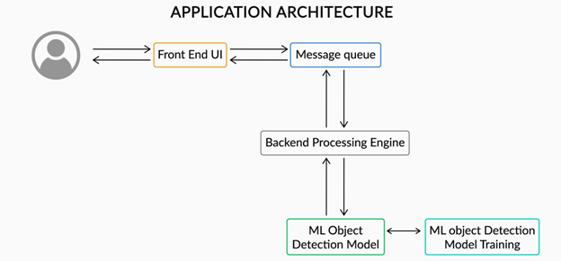

Here is the implementation of the web application in IaaS. Here, we use virtual machines to host each component of the web application. A cloud administrator is required to handle these virtual machines.

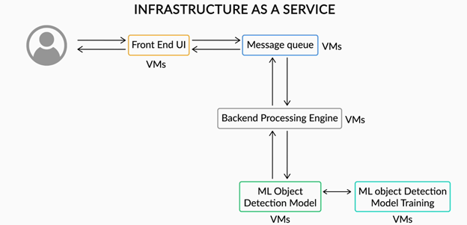

Here is the implementation of the web application in PaaS. Here, we have managed services offered by the cloud to host most of the components of the application. Here, you can see that the number of services used has decreased drastically.

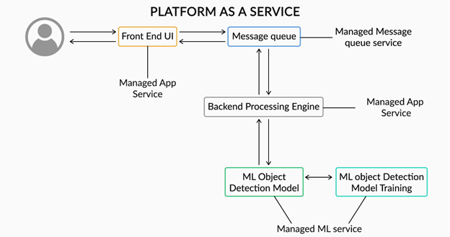

Here is the implementation of the web application in SaaS. Here, the cloud provides the API for taking care of the back-end and machine learning tasks. The user has to just maintain a front-end UI to interact with the API.



Now, here is an overview of the different cloud service models from the perspective of the data centre stack.

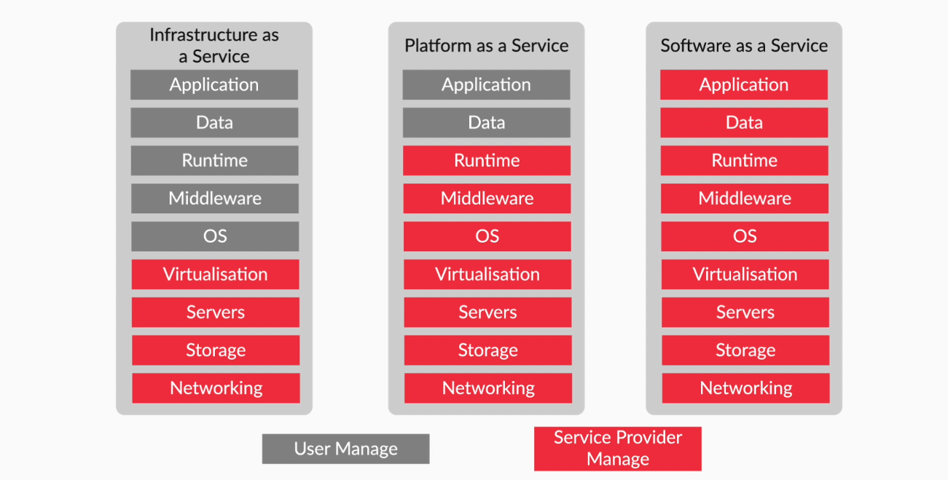

Questions:1/1

Mandatory

**Question 1**

What is the fastest way to deploy a web application? Would you use IaaS or PaaS for this purpose?

Top of Form



IaaS



PaaS

Bottom of Form

Submit

Attempt 1 of 1

So far in this session, you have explored the different cloud deployment and service models. You have also learnt about the popular cloud service providers. In the next session, you will be introduced to Amazon Web Services and get hands-on experience of it.

**Identity Access Management Service**

By now, you must have understood the answer to the question ‘Why AWS?’ Now, it’s time to explore the different services of AWS and get your hands dirty working with them. But before that, you need to understand where AWS data centres are located and maintained. Let’s learn about it from Vinod in the following video.

Replay

Mute

Current Time 1:31

/

Duration 1:31

Loaded: 100.00%

1x

Playback Rate

Quality Levels

Picture-in-PictureFullscreen

So, AWS data centres are located in various geographical locations called **Regions**. The image below shows all the regions of AWS as per December 2019.

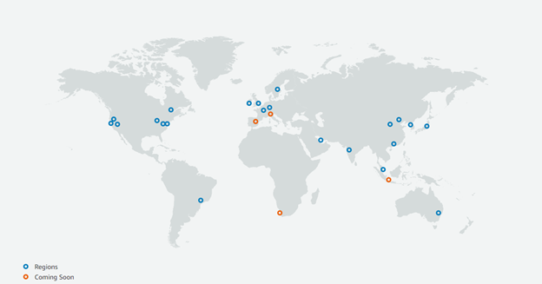

Now, multiple isolated locations with single or multiple data centres within a region are called **Availability Zones**.

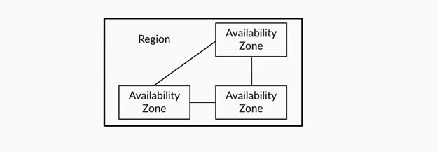

Let us now get into the details of the different AWS services. First, you will learn about the Identity and Access Management service (IAM). Let’s learn more about it from Vinod in the following video.

Play Video

As you learnt in the video, IAM is a management service that allows users to control access to AWS resources. Users are not charged for using the IAM service. Some of the key terms of IAM are as follows:

1. Users
2. Groups
3. Policies
4. Roles

In the next segment, you will explore the key terms of IAM in detail. But before that, we would like to inform you that AWS has an extensive documentation. So, let’s quickly understand what it is and how it is useful from Vinod in the next video.

Play Video

You can access the homepage of the AWS documentation through this [link](http://docs.aws.amazon.com/).

Questions:1/1

Mandatory

**Question 1**

Select all true statements from the options below. More than one option can be correct.

Top of Form



An AWS Region has multiple Availability Zones.



An AWS Availability Zone has multiple Regions.



Using IAM, you can control which user has access to the AWS resources.



Using IAM, you cannot control which user has access to the AWS resources.

Bottom of Form

**Users, Groups, Roles and Policies**

In the previous segment, you were introduced to the IAM service of AWS and learnt about its different key terms, namely, **users, groups, roles** and **policies**. Now, let’s quickly look into each of these terms in more detail.

Play Video

So, with IAM, you can create users and grant or deny them access to AWS resources and services.

1. **AWS root user:** Once you create a new AWS account, you will be provided with single login credentials, namely, your registered email id and password. This account is called a root user and it has complete access to all AWS services. (However, the accounts that you get from NuvePro are not root users.)
2. There are two ways an IAM user can access AWS. These are follows:
   1. Console access
   2. Programmatic access
3. There are three types of IAM users, namely:
   1. Privileged administrators
   2. End users
   3. Programmatic users

If a user 1 wants to access ‘Resource A’, this can be done by granting access to that user. However, let’s say 100 users want to access the same resource; in this case, granting them access individually would be a cumbersome process. This can be done quickly using groups. So, let’s quickly learn about groups in the next video.

Play Video

So far, you have explored two key terms of IAM, namely, **users** and **groups**. Now, how does one control their users or groups to access the AWS resources? Well, this can be done by using IAM policies, which you will learn about in the upcoming video.

Play Video

Now, let's summarise the key points from the video above:

1. **IAM Identities:** Users, Groups or Roles
2. **Resource:** Any entity created by AWS services (for example VM, database, etc.)
3. **Policies** in AWS are JSON documents.
4. Some of the important policy types include the following:
   1. **Identity-based policies**
   2. **Resource-based policies**
5. **IAM Role:** It is an IAM identity that you can create in your AWS account with some specific permissions. Next, this Role can be assumed by any user, service or application to access an AWS resource.

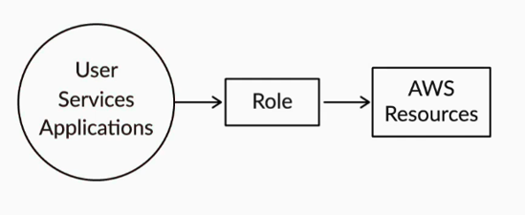

1. Using an IAM role, you can control an Amazon service to access other Amazon services. This cannot be done using policies.  
     
   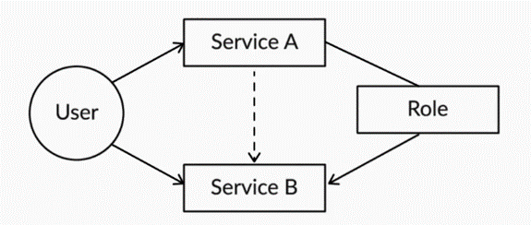

In the next segment, you will first create some resources. Then using the identity-based policy and resource-based policy, you will learn how to control a user to access that resource. In the later segments, after exploring some popular Amazon services, you will also get hands-on experience with roles. But before that, you will learn about some IAM best practices that will help you secure the AWS users and resources.

Play Video

Let's revisit the key IAM best practices below:

1. Delete root user access keys
2. Use multifactor authentication
3. Use groups
4. Rotation of credentials
5. Grant the least privilege of access to any resource

keyboard\_arrow\_leftkeyboard\_arrow\_rightQuestions:1/4

Mandatory

**Quiz 1**

Which of the following are IAM identities?

Top of Form



Users



Groups



Roles



All of the above

Bottom of Form

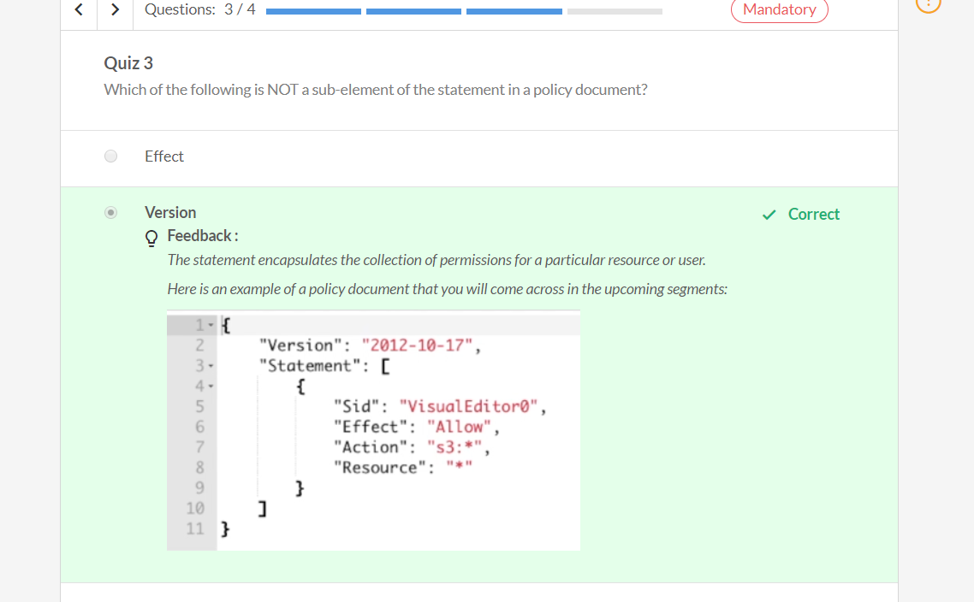

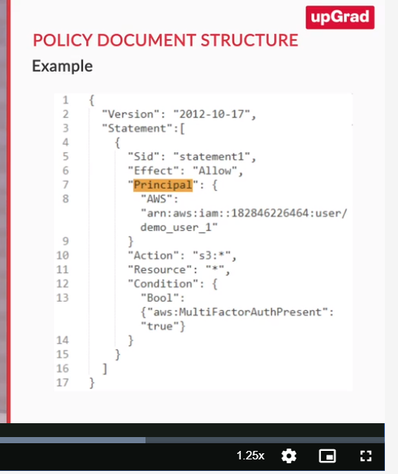

**Amazon Simple Storage Service**

So far, you have explored the IAM service of AWS. You also learnt that using policies you can grant or deny users access to AWS resources. Now, to get some hands-on, you will create some resources using one of the popular Amazon services, namely, Amazon’s Simple Storage Service, which you will learn about in this segment. It is also known popularly as Amazon S3.

Replay

Mute

Current Time 5:45

/

Duration 5:45

Loaded: 100.00%

1x

Playback Rate

Quality Levels

Picture-in-PictureFullscreen

The above steps have been summarised in the document below.

**[Amazon S3](https://cdn.upgrad.com/uploads/production/57a8791f-f9e6-4ea1-8d0e-540077642153/Create+an+s3+bucket+and+upload+object.pdf" \o "Create an s3 bucket and upload object.pdf" \t "_blank)**

[file\_download](https://cdn.upgrad.com/uploads/production/57a8791f-f9e6-4ea1-8d0e-540077642153/Create+an+s3+bucket+and+upload+object.pdf" \o "Create an s3 bucket and upload object.pdf" \t "_blank)**[Download](https://cdn.upgrad.com/uploads/production/57a8791f-f9e6-4ea1-8d0e-540077642153/Create+an+s3+bucket+and+upload+object.pdf" \o "Create an s3 bucket and upload object.pdf" \t "_blank)**

**Amazon S3:** It is an object storage service of AWS.

1. **Uses:**
   1. Backup and restore
   2. Archiving purposes
   3. Hosting static websites
2. You can upload any type of file, such as images, csv, etc., to Amazon S3.
3. It offers 99.999999999% durability and 99.99% availability.
4. Some of its key concepts include the following:
   1. **Object:** Any file that is stored in Amazon S3 is considered an object.
   2. **Key:** It is a unique object identifier. It can be used to retrieve an object from Amazon S3.
   3. **Buckets:** The objects in Amazon S3 are stored in Buckets. It has a unique name globally.
   4. **Versioning:** You can also maintain the version of an object in Amazon S3.

In the next video, you will learn more about Amazon S3 by exploring other key concepts.

Play Video

So, here is a list of the points that were covered in the video:

1. All buckets in Amazon S3 are private by default. You can make them public by modifying the bucket properties.
2. Uploads to Amazon S3 are atomic.
3. Amazon S3 provides read-after-write consistency.
4. Some of the popular Amazon S3 storage classes include:
   1. S3 standard
   2. S3 intelligent tiering
   3. S3 infrequent access
   4. S3 glacier
5. The cost of Amazon S3 depends on:
   1. The region where the S3 is located
   2. The size of the data stored
   3. The duration of the data in S3
   4. The object access request

So, now that you have the understanding of Amazon S3, it is time for you to make your hands dirty by working on the Amazon S3. You will now learn how to make the uploaded file publicly available and also learn how to maintain the versioning of a file.

Play Video

**Note:**If you are planning to use the same bucket in future, remove the public access before proceeding ahead.

So, you learnt that if a user wants to make an object public, then they need to follow the steps below:

1. First, they should enable public access to the bucket, and then
2. Make the object public.

You also learnt how to maintain different versions of a file in S3 by setting versioning on the bucket. Also, You must remove this component from the bucket as you will be charged for maintaining different versions of the bucket.

Now that you have a good understanding of Amazon S3, you will next learn how to control the user to access Amazon S3 resources.

Play Video

In the video above, you first learnt how to allow a user access to the AWS S3 buckets using the identity-based policy. Then you learnt how to deny the same user access to the S3 buckets using the resource-based policy.

Now, answer the following questions based on all that you have learnt thus far.

keyboard\_arrow\_leftkeyboard\_arrow\_rightQuestions:1/4

Mandatory

**Quiz 1**

Suppose you created a bucket in Amazon S3 by blocking all public access and then uploaded an object to it. Now, if we just change the permissions of the bucket as public, will the object be publicly available or not?

Top of Form



Yes



No

Bottom of Form

**Amazon Elastic Compute Cloud**

Now, you will learn about another popular amazon service, Amazon Elastic Compute Cloud, which is popularly known as **Amazon EC2**. In the upcoming segments, you will learn how to connect Amazon S3 from Amazon EC2 using a role.

Play Video

Features of Amazon EC2:

1. It provides a virtual computing machine on AWS.
2. You will require a key pair to log in to an EC2 instance. (You will understand this better once you move on to the hands-on part of it)
3. Amazon EC2 provides various instance types based on the requirements. The instance types are broadly classified as follows:
   1. Computing
   2. General Purpose
   3. Memory Optimised
   4. Accelerated Computing
4. It also provides some preconfigured operating system templates with some pre-installed software. The templates are called Amazon Machine Images (AMIs).
   1. You can also build custom AMIs and directly launch them as per requirement in the future.

There are four EC2 instance types in pricing perspective, which you will learn in the next video.

Play Video

There are broadly four different instance types that users can utilise as per their requirements in order to optimise cost. The instance types are as follows:

1. On-Demand Instances
2. Spot Instances
3. Reserved Instances
4. Dedicated Instances

To help users to maintain their privacy, prevent them from losing data and provide security effectively, AWS comes with amazon virtual private cloud and security groups. Let’s learn about them from Vinod.

Play Video

By using VPCs and Subnets, you can make your database private and allow only your application to access the data that is publicly available. To understand these technical terms better, please refer to this [link](https://medium.com/tensult/intro-to-vpc-548b69f1bd1f).

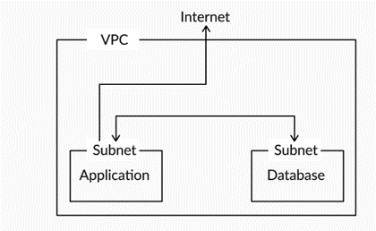

You also learnt that the end user can use security groups to specify which IP addresses can be allowed to access the instance of a specific port.

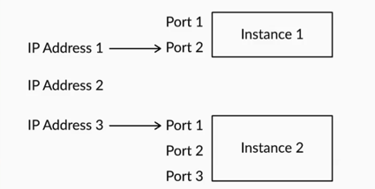

Now, based on everything that you have learnt so far, answer the following questions:

Questions:1/1

Mandatory

**Quiz 1**

Suppose you are working on a machine learning project and want to conduct machine learning training that requires in-memory calculations. Which of the following types of instance best suits this case?

Top of Form



Compute instance



Memory-optimised instances



General-purpose instances



Storage-optimised instances

Bottom of Form

Submit

Attempt 1 of 2

In the next segment, you will have the hands on experience with AWS EC2 where you will connect Amazon S3 from Amazon EC2 using an IAM role.

**Amazon RDS and AWS Lambda**

In this segment, you will learn about two of the popular services provided by Amazon. They are Amazon RDS and Amazon Lambda. Let’s first understand what Amazon RDS is from Vinod.

Replay

Mute

Current Time 4:51

/

Duration 4:51

Loaded: 100.00%

1.25x

Playback Rate

Quality Levels

Picture-in-PictureFullscreen

Amazon RDS is a distributed relational database service.

1. It is the PaaS offered by AWS.
2. DB instance is the core part of RDS.
   1. It is an isolated database environment in AWS.
3. There are different storage types in RDS:
   1. General-purpose SSD
   2. Provisioned IOPS
   3. Magnetic
4. It also provides a wide range of instance types. The two main types are as follows:
   1. General-purpose instance types
   2. Memory-optimised instance types
5. DB instances from a pricing perspective are as follows:
   1. On-demand DB instances
   2. Reserved instances

Now that you have understood what Amazon RDS is, let’s quickly learn how to create and delete an RDS instance in AWS.

***IMPORTANT:* The video below only for demonstration purpose. You must use the documentation provided below to launch an RDS instance. It is mandatory for you to use only 'db.t2.micro' instance type for your practice purposes.  You are not supposed to use other instance types unless it is mentioned to you. Violating this could lead to expire your monthly budget.**

Play Video

All the steps have been provided in the following document.

**[RDS instance](https://cdn.upgrad.com/uploads/production/87eb4354-11cf-4d8f-bdf6-d47e09814a32/RDS+Documentation.pdf" \o "RDS Documentation.pdf" \t "_blank)**

[file\_download](https://cdn.upgrad.com/uploads/production/87eb4354-11cf-4d8f-bdf6-d47e09814a32/RDS+Documentation.pdf" \o "RDS Documentation.pdf" \t "_blank)**[Download](https://cdn.upgrad.com/uploads/production/87eb4354-11cf-4d8f-bdf6-d47e09814a32/RDS+Documentation.pdf" \o "RDS Documentation.pdf" \t "_blank)**

In the next video, you will learn about another popular service offered by Amazon, AWS Lambda, which you can use to run your code without managing any server. It will automatically scale based on the requirement. Let’s learn more about it from Vinod.

Play Video

**AWS Lambda**

1. It is a serverless computing platform offered by AWS.
2. It allows users to run any code without worrying about the management of servers.
3. Users have to pay only for the computing time they consume to run their code.
4. Users have to just upload their code to AWS Lambda; it takes care of everything that is required for scaling any resources and running the code.
5. Users can trigger the code on AWS from any other AWS services, the web or any mobile applications.
6. Every user's code is executed parallelly.

So, you learnt how to run a simple Python code using AWS Lambda. Now, based on everything that you have learnt so far, answer the following questions.

keyboard\_arrow\_leftkeyboard\_arrow\_rightQuestions:1/4

Mandatory

**Quiz 1**

Which of the following options is the core part of AWS RDS?

Top of Form



Storage types



DB Instance



Instance types



None of the above

Bottom of Form

**Summary**

Here’s a summary of what you have learnt so far in this session:

1. You began by understanding Amazon Web Services. Then, you explored regions and availability zones of AWS.
2. You learnt about some basic and popular Amazon Services. You started with IAM and explored the four key concepts of IAM, which are as follows:
   1. Users
      1. Created a user in AWS
   2. Groups
      1. Created a group in AWS and added an existing user to this group
   3. Policies
      1. Explored identity-based policies and resource-based policies
   4. Roles

1. You explored another popular service offered by AWS, Amazon Simple Storage Service, which is also known as Amazon S3.
   1. You learnt how to grant a user access to Amazon S3 buckets using identity-based policies.
   2. You learnt how to deny the same user access to the Amazon S3 buckets using resource-based policies.
2. You explored the Amazon Elastic Compute Cloud and learnt how to create an EC2 instance and connect to it from the local system.
   1. You learnt how to access Amazon S3 buckets from an EC2 instance using a role.
3. You explored some of the popular services offered by AWS. The following are two of them:
   1. RDS
      1. You learnt how to create and delete an RDS instance.
   2. Lambda
      1. You learnt how to run simple Python code on Lambda.

AWS provides a price calculator tool that reads the types of services and some usage values as input and gives an estimated monthly cost. In the following video, you will learn how to estimate the cost based on the usage of resources. Please find the AWS price calculator tool [here](https://calculator.s3.amazonaws.com/index.html).

**MLC\_B01\_1.3.4\_Ver 03\_Video 03**

Play Video

2041292

**Report an error**

**PREVIOUS**

Amazon RDS and AWS Lambda

**NEXT**

Graded Questions

<https://calculator.s3.amazonaws.com/index.html>